Install Heroku
Link: https://devcenter.heroku.com/articles/getting-started-with-nodejs?singlepage=true#set-up
- Download and install Heroku.
- Restart your Hyper Terminal.
- Login to Heroku.
$ heroku login
- Perform the following commands in Hyper.
$ git init
$ git add .
$ git commit –m “...”
$ heroku create
$ git push heroku master

Deploying the Application to Heroku
- In your Hyper Terminal enter the following commands:
$ heroku create create a brand new app in heroku
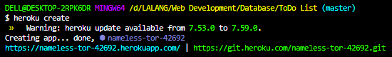

- Add a “Procfile” and make sure it’s at your application’s root directory:
$ touch Procfile make sure file is copied word for word
no extensions allowed

- Open “Procfile” and add the following lines:
web: node app.js web, tells it that it’s a web application and to start it, the entry point is at app.js
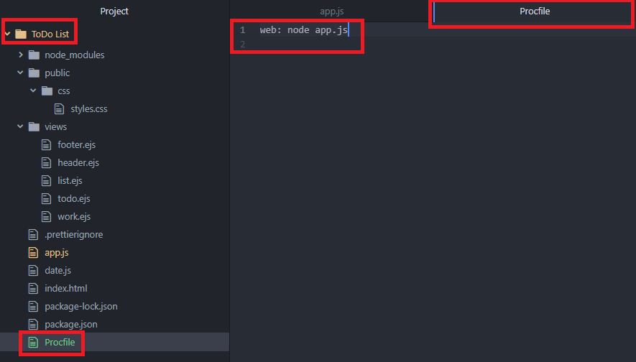

- Set your application code to listen the correct port
// Listening to the correct port locally/heroku
let port = process.env.PORT;
if (port === null || port === "") {
port = 3000;
}

app.listen(port, () => {
console.log("Successfully connected. Listening to port ", port);
});

- Use a database or object storage instead of writing to a local file system.
Use a database server to store your data.
MongoDB Atlas is an option, to connect to an existing cluster/project, please check on the MongoDB documentation: Connect MongoDB Atlas to the Application

- Complete the language-specific setup.
Currently, we’re using NodeJS so we have to specify the version of Node we’re using.
Add this to your application’s package.json file (under the “license” field):
"engines": {
"node": "14.x"
},
},
- Create a .gitignore file to ignore unnecessary dependencies and other files being uploaded to Heroku. Make sure the file is placed in the application’s root directory.
$ touch .gitignore to create a .gitignore file
Add the following to .gitignore file:
/node_modules
npm-debug.log
/*.env

- Add all the changes to the Staging Area in Git, commit, and then Push to Heroku
$ git add .
$ git commit –m “Add .gitignore, Procfile, and update Port”
$ git push heroku master

If you receive an error when pushing:
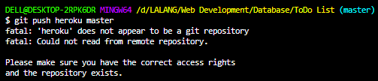
Solution 1: Initialize git for your project, add the changes and perform a commit
$ git init
$ git add .
$ git commit -m "first commit"

Create Heroku app and push to Heroku
$ heroku create
$ git push heroku master
Or
Solution 2: This worked for me. Just needed to run Heroku create again. For some reason the first time didn't create a git remote so before you “push” you need to add
$ heroku git:remote -a yourapp
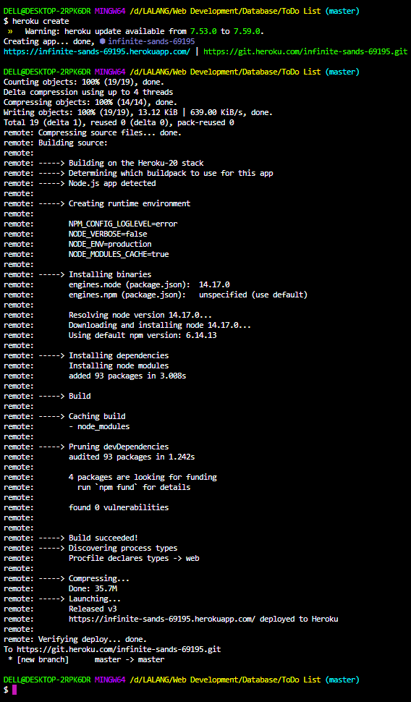
- dfasdf

